GL_BEATS

Table Name:

1. Album: album_id, title_name, artist_id
2. Artist: artist_id, artist_name
3. Customers: customer_id, first_name, last_name, company, customer_address, customer_city, customer_state, customer_country, postal_code, customer_phone, fax_number, customer_email.
4. Genre: genre_id, genre_name
5. Invoice: invoice_id, customer_id, invoice_date, biling_address, billing_city, billing_state, biling_country,biling_postal_code, total_price
6. invoice_items: invoice_line_id, invoice_id, track_id, unit_price, quantity
7. Mediatype: media_type_id, media_type_code
8. Menu: dish_id, dish_name, price
9. Playlist: Playlist_id, playlist_name

(10) Playlisttrack: playlist_id, track_id

(11) Tracks: trck_id, track_name, album_id, media_type_id, genre_id, composer, miliseconds, bytes, unit_price

**24 September 2022**

##...........How to find Top 10 Values in the table...............

select *

from customers

limit 10;

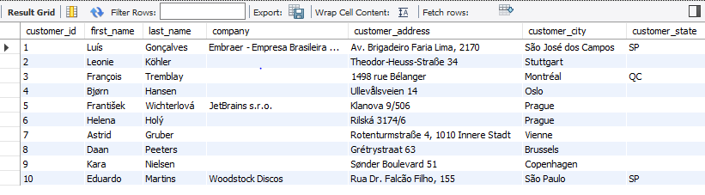

##............User want to see all the Data of Customers from Brazil...............

select *

from customers

where customer_country = "Brazil";

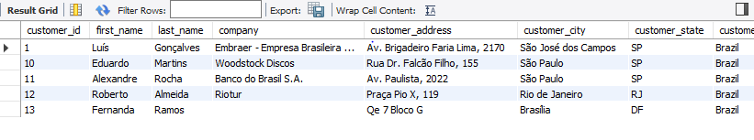

##....................Find out People from Brazil and Canada........................

select *

from customers

where customer_country in ("Brazil","Canada");

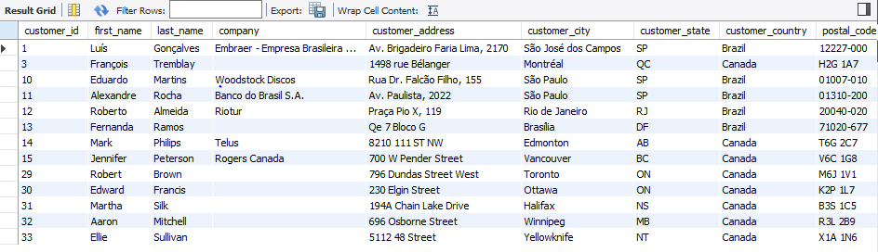

##...........................I want to see Customer_ID 5 and 9..........................

select *

from customers

where customer_id in (5,9);



##......Details of the Customers who is not working in any of the Company............

select *

from customers

where company != ' ';